**Computer Programming 1  
Essential Standard 6.02 Apply Decision Structures  
Challenge Exercise**

1. Create a new project called RockPaperScissors. Add the controls shown with appropriate names. In this exercise you are going to create a Rock, Paper Scissors game.   
   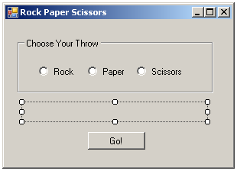
   1. Create a variable to hold the computer’s choice.  
      Generate a number between 1 and 3, inclusive to represent this choice.  
      A 1 equals Rock, a 2 is Paper and a 3 is Scissors.
   2. Use a Decision statement to compare the user’s choice, represented by the RadioButton click, and the computers choice to decide the winner.
   3. Create “counters” to represent Wins, Loses and Draws.
   4. When the Go button is clicked
      1. Display who won in a MessageBox.
      2. Display the wins, losses and draws in the label.